**8 Phase of SDLC:** Plan code build test deploy release operate and monitor

**Goal of Devops:** bringing efficiency and effectiveness in SDLC. (Cultural change)

**Two pillar of application** 1) Development Team 2) Operation Team

How Development team works?

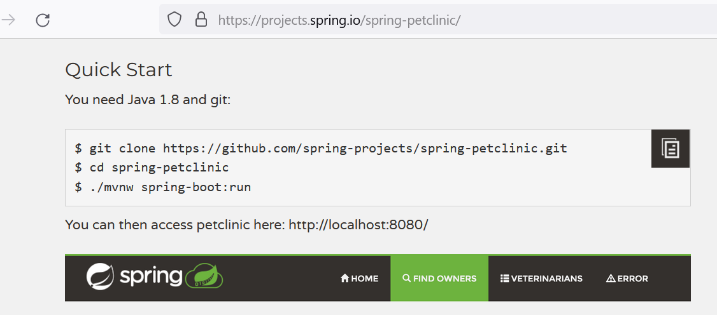

How Operation team works? >> Create infra as per Application team, and run software.